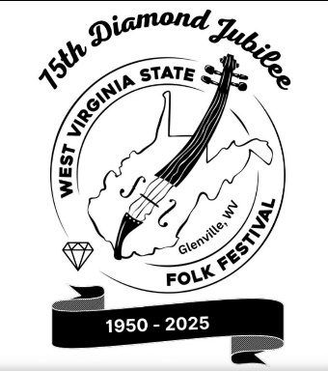
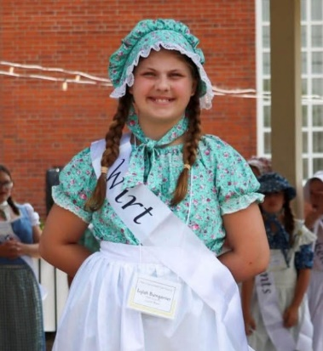
Saturday, Luncheon Attendance

Luncheon is held at Glenville State University Ballroom

Lunch will be provided for Junior Belle’s at no cost. This luncheon is also with the Festival Belles (ladies 70 and older) and will be held on the Glenville State University campus. Other family members that wish to attend will need to pay $12 per person.
Please return this sheet with payment by May 15, 2026
PayPal payments may be made to wvstatefolkfestival@gmail.com
or
It can be mailed to WV State Folk Festival Junior Belle, 32 Quarry Dr, Glenville, WV 26351

Names of Attendees
Name of Attendees | $12.00
Junior Belle Name: | free

Total Number Attending the luncheon and Check made to WV Folk Festival Junior Belle Number attending ______ x $12.00 = ________________ Total Cost

Tickets will be mailed to you for the luncheon once money is received!

