West Virginia State Folk Festival Junior Belle
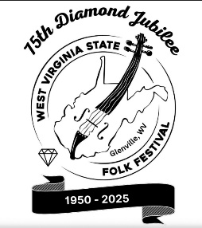
Who
Each County Extension Office may select one “Junior Belle” who:
- Is a 3rd or 4th grader
- Is a member of her county 4-H club, if possible
- Will enjoy the festival and make new friends
- Participates in Saturday’s Parade (walking three level blocks) in her country-style dress (preferably with a bonnet). You will need to have a 2” white sash with your county name on it! These will not be provided.
What
The West Virginia State Folk Festival is the oldest celebration of our Appalachian roots. Music is the primary focus; the youth may also enjoy crafts and demonstrations, square dancing downtown, pet show, spelling bee, wagon rides, and other activities.
Why
Junior Belles represent their county and are honored guests at the parade and luncheon Saturday and are young ambassadors for their county. They will be formally introduced at City Park following their luncheon.
Where
The festival is in Glenville, in the heart of central West Virginia. The festival is held at various downtown locations. Following the 11 a.m. morning parade, the young Belles will be treated to a family luncheon along with suggested afternoon activities on Saturday, June 20th. The Junior Belle meal is provided, but family members are asked to pay $12 per person. Please submit payment for any attendees prior to May 15, 2026. They may be made payable to WV State Folk Festival, Junior Belle, 32 Quarry Dr, Glenville, WV 26351. Paypal payments are accepted at wvstatefolkfestival@gmail.com
When Saturday, June 20th - Junior Belles are only asked to be present on Saturday for their events. No overnight accommodations will be provided.
DEADLINE: The festival reserves the right to use alternative methods after February 14 to select a young lady from any county who has not yet submitted!

